

Arab American University

College of Graduate Studies

Name of the master program

MASTER IN COMPUTER SCIENCE

Research Proposal

**Silicon Wafer Defects Classification Using Deep Learning Techniques**

**تصنيف عيوب رقاقة السيلكون باستخدام تقنيات التعلم العميق**

Student’s Name: Hussein Salah Younis

E-mail address: h.younis1@student.aaup.edu

Mobile number: 0599841297

Date: 15/2/2023

Supervisor Name:

**Instructions:**

**1- Use the boxes given below for each paragraph to include your text.**

**2- Please keep the text which describes the task (given in blue)**

**3- Try your best to be precise and just include what has been requested in the box**

**4- Do not change the layout or the font size, just use the template as is**

EXECUTIVE SUMMARY

Define the topic in general terms

Employing artificial intelligence and deep learning in many industries field, especially in semiconductor wafer manufacturing is a fast-growing new research field. This research field is driven mainly by the desire to develop a deep learning model to improve the accuracy and performance in classifying different types of defects in wafer maps. Through this study, we will try to solve a problem that exists in the manufacture of semiconductor chips that causes significant losses to manufacturing companies represented by defects in the wafer. This study will be as a partnership between the Arab and American universitiy and the Grenoble Alpes centre in France.

Clearly state the research problem

Semiconductor wafer manufacturing processes are complex, and costly and need high accuracy to produce a high-quality final product. Therefore, inspection and testing at each stage are very important that require the intervention of semiconductor engineers to make decisions and identify and track defects in the outputs of each stage which need time and high accuracy.

Define the objectives of the study

This study aims to experiment to identify and appraise existing deep learning algorithms based on literature to classify different types of defects in wafer maps. In addition, we will try to develop a hybrid model of a deep learning algorithm capable of classifying the defects in semiconductor wafer maps with high precision. The main objectives of the study are (1) Highlight deep learning and its important algorithms in the fields of semiconductor wafer manufacturing. (2) Improve the quality of manufacturing final products for semiconductor wafers and reduce the associated cost of addressing defects in them. (3) Examine and implement several deep learning models proposed by researchers using a real dataset. (4) make a comparison of the performance and accuracy of different types of deep learning algorithms in classifying defects in a wafer map.

Describe the method to be used

A mixture of qualitative and quantitative methods will be used in this study: (1) qualitative method by explaining deep learning and its algorithms in detail. (2) quantitative method (Experimental) by conducting experiments to examine different types of deep learning algorithms and obtain numerical results. Identifying deep learning algorithms will be determined based on the literature. Many experiments will be performed with different types of deep learning algorithms in a python environment to obtain results. As far as data analysis is concerned, many Statistical analysis methods will be used to analyze the result.

Describe the expected outcomes

This study will provide non-biased results for the performance and the accuracy of different types of deep learning algorithms and thus provide a comparison between them to obtain the most accurate deep learning algorithm to detect the various type of defects in wafer maps based on the selected dataset. This study will also provide a hybrid model of a deep learning algorithm capable of classifying the defects in semiconductor wafer maps with high precision.

State the significance of the study

This study highlights the importance of the usage of deep learning in the field of machine learning to classify different types of defects in the wafer map. Thus, providing an impartial study of the importance of employing such technologies in improving and reducing errors and cost in many industrial fields, especially in semiconductor wafer manufacturing.

1. Introduction

Briefly describe the topic to an educated non-specialist person:

The growing acceptance of digitalization, along with improved connection, is significantly boosting demand for electronic devices. Statistics indicate that the global consumer electronics market size is expected to reach USD 1344.50 billion by 2026 [1]. An electronic device consists of many integrated circuits (IC) which is a collection of electronic components such as resistors, transistors and diodes…etc. These electronic components and their interconnections are constructed on a thin semiconductor wafer made mainly from highly pure single-crystal silicon [2].

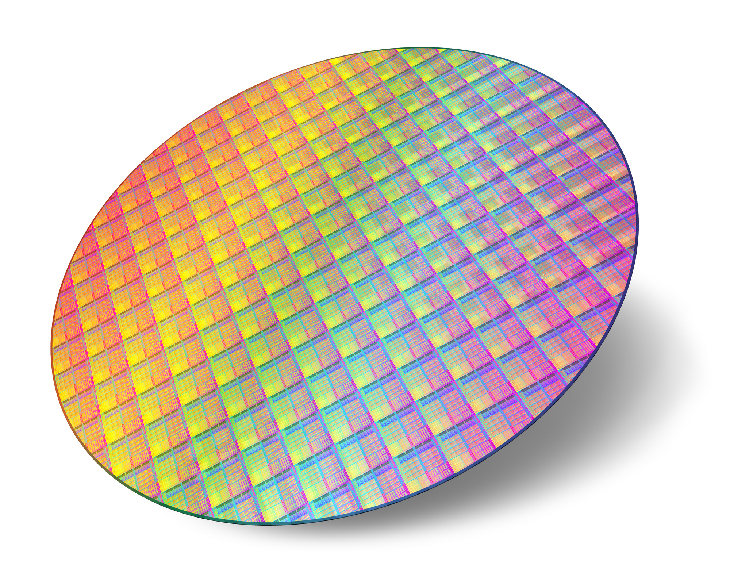

Figure 1: Silicon Wafer (source: <https://www.linseis.com/en/applications/thin-film-technology/> )

Semiconductor wafer manufacturing is a series of costly, complicated, and highly disciplinary procedures. This necessitates the use of specialized equipment to achieve the required precision at a nanoscale. Typically, a semiconductor manufacturing process takes up to 26 weeks [3]. during the manufacturing process, there are two main sources of defects in the wafer: the dust particles in the manufacturing environment and the equipment and human errors [4]. This, therefore, requires complex and time-consuming diagnosing, inspection and analysis processes in each step to detect defects in it which helps engineers to track and handle the source of failure in each stage before reaching the final production stage and to ensure that the components are aligned correctly and they operate correctly in a desired manner. Thus, this process may be almost impossible for all stages of manufacturing.

In general, there are many methods for the inspection process, the popular one is the automated inspection machines test that produces a wafer map which is a graphical colored visualization image presenting the location of defects on the silicon wafer and other important information for tracking and manufacturing process [5]. Figure 2 shows an example of a wafer map.

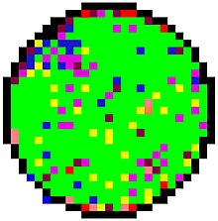

Figure 2: A sample of a wafer map (source: <https://en.wikipedia.org/wiki/Substrate_mapping> )

The wafer map indicates for each die of the wafer if it passes or fails in meeting performance standards [6]. Thus, a spatial pattern of wafer maps can be derived to classify whether the wafer production met the performance standards or not and also identify exactly which die in the wafer contains a defect. Based on the inspection test, engineers can identify the causes of the defects in the wafer in each step, address them, improve the production lines and reduce the production cost as possible.

Given the significant technological breakthrough in the Fourth Industrial Revolution in many areas, including artificial intelligence, it is possible to use this technology in the semiconductor manufacturing process and try to solve the existing problem by using deep learning algorithms in the classification of defects in wafer maps.

Deep learning is a subset of machine learning which is a subset of artificial intelligence that enables machines to mimic human behaviour by teaching them to analyze data like the human brain [7]. Deep learning is derived from artificial neural networks (ANN) which consist of inputs, hidden and output layers that are connected by neurons. Figure 3 demonstrates the general structure of ANN [8].

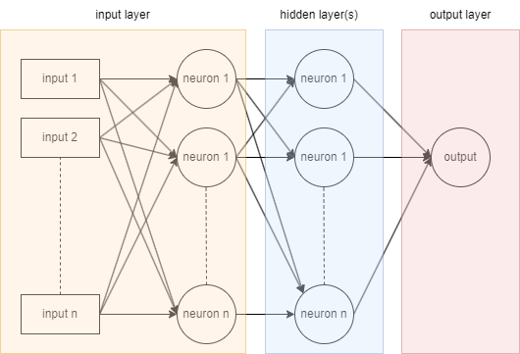

Figure 3: general structure of ANN.

In our case, the neural network is trained to identify wafer map images with dimensions of MXN pixels. Each pixel of the wafer image is fed to a neuron in the first layer where each neuron has a unique number called a bias. The information is transferred from one layer to another over connecting channels where each channel is associated with a value called a weight.

For each neuron, the sum of weighted outputs is calculated by the Equation 1 which represents the summation of the product for each input connected to it with the weight value associated with a related channel is used to calculate the activation function value.

$the sum of weighted outputs =\sum_{i=1}^{n}{x_{i}w_{i}}$ (1)

Different types of activation functions are used in a neural network, the popular one is the sigmoid function $σ$ which is defined as [9]:

$σ\left(x\right)=\frac{1}{1+e^{-x}}$ (2)

Where x represents the input, e is the Euler's number which is approximately equal to 2.781 [10] and the range of $σ$ is from 0 to 1.

Based on the activation value, the information is transferred to the next layer. This process is continued until the inputs have passed through all layers and then the output value is calculated [11].

Based on the description given above, describe the research problem or issue in more details:

Due to the complexity of semiconductor wafer manufacturing, the probability of defects in the wafer is very high. Many scientists and researchers in this field classified defects into eight categories based on their distribution in the wafer map [10]. Figure 3 shows the eight types of defects in the wafer map namely: (1) center, (2) donut, (3) edge-local, (4) edge-ring, (5) local, (6) random, (7) scratch and (8) near- full.

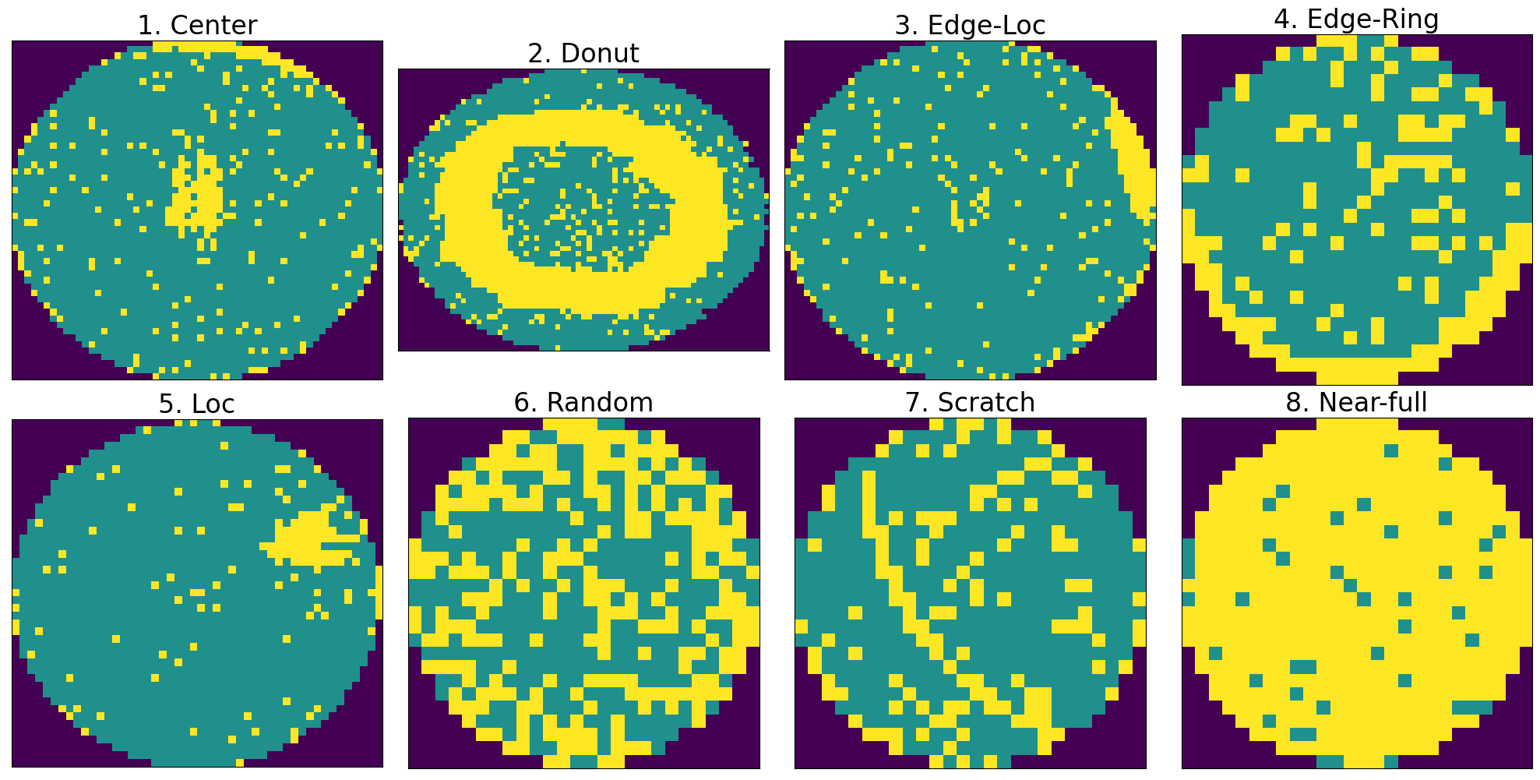

Figure 3: wafer map defects types (source: generated by a python code from WM-811K dataset <https://www.kaggle.com/datasets/qingyi/wm811k-wafer-map>)

Although many existing technologies are used to analyze the wafer map and to discover defects, human engagement by expert engineers is also still required to manually ascertain the results, and so this procedure requires significant time, tedious work, and high accuracy in detecting and tracking defects.

Using deep learning can contribute to solving this existing problem and classifying defects with high accuracy based on wafer maps.

Explain why it is interesting and relevant to your field of study:

This scientific research field is relatively new in the Arab world. According to previous literary studies, there is no previous research about this topic in the Arab world. This is one of the primary reasons I am interested in this topic. Furthermore, as a bachelor's degree holder in computer systems engineering, topics that incorporate both hardware and software interest me. In addition, this study attempts to solve a real problem that exists through what was discussed with Mr Jeremy Perret (CIME-P, Project Manager) from Grenoble Center.

Describe how your study will contribute to the body of knowledge on the topic:

The contributions of this study are summarized as follows:

1. Trying to solve an existing problem in the area of the semiconductor manufacturing process by employing various types of deep learning algorithms in the classification of defects in wafer maps.
2. Provide an impartial study of different types of existing deep learning algorithms in classifying defects in wafer maps and thus open up the possibility for researchers to research further in this field.
3. Proposed a hybrid deep learning model that can classify defects in wafer maps with high accuracy and with optimal performance.
4. LITERATURE REVIEW

The purpose of this section is to prove that there is still a gap in the existing knowledge related to the subject of the research question. So, this part will answer the question of why we should conduct this research. To be able to compile this section, search, find and analyze other studies that address similar research issues, or studies that address your research question in different settings.

Introduction: Define your research question

Clearly define your research question and explain to the readers that you will demonstrate how the studies you have analyzed and summarized do not answer your research question in particular.

1. Are deep learning algorithms capable of classifying different types of defects in wafer maps with high accuracy?
2. Is employing deep learning will contribute to solving the existing problem and provide a realistic solution to this problem?
3. If there is a limitation in obtaining real wafer map dataset due to that most manufacturing companies refuse to provide researchers with original wafer maps, can we rely on augmented data to train different types of deep learning models and obtains good result in classifying defects in wafer map?
4. If a hybrid model is developed that combines with the latest findings of researchers in the field of deep learning, will there be a marked improvement in the accuracy of the defect’s classification in wafer maps?

Body: Summarize published literature: Elaborate on existing relevant research, debates and findings…

This part should be organized to summarize and present the findings and results of others studies. The researcher should find a way to organize the review, might be by dates, by geographical location, economic and social status, by topic, etc.

The main purpose of this part is to show that there is a knowledge gap in the body of knowledge that can not be filled unless the research project is completed.

In [13], the authors used the You Only Look Once (YOLO) architecture to construct a convolutional neural network model to locate and classify eight types of wafer map defects. The authors used a public dataset called “WM-811K dataset” to train the proposed model and they achieved a mean accuracy of 72.3% for all types of defects using YOLO version 3 and about 75.8% using YOLO version 4. The result they obtained shows that the accuracy was bad for detecting edge-local, local and scratch defects.

Other authors proposed a neural network model for detecting and classifying wafer defects taking into account performance and memory consumption. In [14], the authors develop a binarized neural network model to reduce time and memory consumption to detect and classify wafer map defects. The authors used a public dataset called “WM-811K” to train the developed model and they archived an overall accuracy of 94.83% and memory reduction of 1.10-25.93x.

In [15], the author proposed two models based on convolutional neural networks (CNN) and extreme gradient boosting (XGBoost) to detect defects in wafer maps. Also, the author compares the performance and the accuracy of the proposed model in defects classification with random decision forests (RF), support vector machine (SVM) and adaptive boosting (AdaBoost). The experiments show that the proposed models have outperformed other algorithms, thus the overall classification accuracy of CNN achieved 99.2% and the XGBoost achieved 98.1%.

In [16], the authors proposed a model for classifying wafer defects based on eight defect patterns using an incremental learning approach with four phases to learning the Deep convolutional neural network model. The authors used a public dataset called “WM811K”. for data preprocessing, the authors used constrained mean filtering to reduce noise in the dataset. The results show that the overall accuracy is 97.7%. however, the results they obtain show that there was a discrepancy in the accuracy of the classification of defects as the accuracy of classifying the local type of defect achieved about 79% and for scratch type just 75.2%.

Authors in [17] relied on synthetic binary wafer maps instead of real wafer maps to generate abnormal defects datasets to train Deep ConvolutionalEncoder–Decoder Neural Network model. The authors constructed three different types of neural network architectures namely: semantic segmentation model (SegNet), U-shaped encoder-decoder network (U-Net) and Fully Convolutional Network. By examining these models using a real wafer map dataset, the results showed that the mean training accuracy is 98%, 99% and 97.8% for U-Net, SegNet and FCN respectively. Also, the result shows that for the random defects pattern, there was an error in detection (about 5%).

some authors rely on an unbalanced dataset for wafer maps to train a neural network model as in [18]. They addressed that by data augmentation technique based on CNN encoder-decoder to generate a new balanced dataset. The result they obtained shows that the proposed model can classify defects using the original dataset with a test accuracy of 87% and with the modified dataset with a test accuracy of 97%. Others used a convolutional auto-encoder model to handle unbalanced dataset issues as in [19]. They proposed a novel methodology to classify defects in wafer maps using deep selective learning and to classify new patterns for wafer defects. The authors used a public dataset called “WM-811k” to conduct experiments and they achieved an overall accuracy of 94% in detecting the known pattern of defects and an accuracy of 99% for detecting the new pattern of defects.

Conclusion: present the ‘why this study’

In this part, briefly restate your research question and indicate how other researches addressed similar or related questions but did not answer your research question for your chosen population, topic and/or research method.

For example, point to studies that addressed the effects of some reading intervention on elementary school students but not on eighth-grade students. Or point out that a qualitative study was conducted using one subject, but your focus is a quantitative study using a much larger population sample. Convince your reader that your study will fill a void in the research that already exists.

This study attempts to deal with a real problem in the field of the semiconductor manufacturing process. Through meetings with the Grenoble Alpes center teams from France, which is a specialized center in nanotechnological, they explain that there are significant losses for manufacturers as there are some defects that are detected only at the end of the production line. In addition to that, the inspection process for each step-in wafer fabrication is very complex and unreliable.

This study, therefore, highlights the importance of using deep learning techniques to detect and classify defects in wafer maps and proposed powerful different types of deep learning algorithms that can be included in the inspection process in the production line to increase the quality of production and to accurately detect defects in an earlier stage.

Describe your contribution: briefly state how your research idea will add to the existing body of knowledge of the subject matter and fill in the research gap.

The main contributions of this study are to solve an existing problem in the area of the semiconductor manufacturing process by employing various types of deep learning algorithms in the classification of defects in wafer maps and to provide an impartial comparison study of different types of existing deep learning algorithms in classifying defects in wafer maps, opening up the possibility for researchers to further research in this field.

1. METHODOLOGY

In this section, you need to give details about how you will obtain and analyze your data to answer the research questions formulated above. Include the following items:

Indicate what kind of research methodology you will follow; whether it is quantitative, qualitative, or both. Explain why you have decided to follow that approach to fit the research problem:

A combination of quantitative and qualitative approaches will be used in this study because this study will provide a literary review of the most important deep learning algorithms by explaining these algorithms and the methodology used. also, an experimental analysis of these algorithms will be conducted by performing many experiments and control of variables to obtain the best results. Perhaps the most important reason for following this methodology and conducting experiments is that the outputs of the inspection process currently followed at all stages of semiconductor manufacturing depend primarily on image analysis for wafer maps. Deep learning provides a suitable mechanism for extracting many elements of images and thus the ability to classify new inputs accordingly, taking into account the performance and accuracy. As a result, detect defects in the wafer based on the wafer map accurately as possible.

The main steps in the proposed methodology are as follows:

1. Select deep learning algorithms based on literature.
2. Identify the dataset.
3. Analysis of the dataset.
4. Preprocessing the dataset: (a)clean the data by removing empty and duplicated rows. (b) check if the dataset is unbalanced and resolved it. (c) handles outliers in the dataset.
5. Train the deep learning models.
6. Test the deep learning models.
7. Readjust models’ parameters to obtain a better result.
8. Analyze result.

Describe the data collection method you will be following:

Based on the literature, deep learning algorithms will be selected, also the dataset will be obtained from the Grenoble Alpes center in France. if that was not possible, the dataset will be selected from the Kaggle website.

Describe the research population and the sampling method you will be targeting:

The population of this study is the selected deep learning algorithms and all data in the dataset will be used after determining preprocessing phase, the feature selection will depend on univariate statistical tests that will be used.

Explain how you will analyze your results and answer the research questions

The results will be analyzed using main classification metrics like accuracy, precision, recall, F-measure and confusion matrix. Through these methods, acceptable results can be obtained through experiments and make a comparison between different selected deep learning algorithms as well as comparing them with each other and thus laying out general lines to what deep learning algorithms have reached and see if it is possible to obtain reliable competitive results. As a result, get answers to the study's questions.

1. **POTENTIAL OBSTACLES**

In this section, you need to mention any potential limitations that might hinder your study. Include the following;

Are there any practical limitations that might hinder your data collection:

One of the most important challenges facing researchers in this field is the acquisition of datasets since most semiconductors manufacturers monopolize the designs of electronic circuits. Therefore, the Grenoble Alpes center from France was formally approached through Dr Amjad Rattrout to provide us with a dataset as soon as possible on 23/1/2023. The first reply from them was that they are very interested in the proposed study but they can’t provide us with the required information. In addition, they ask for a meeting to discuss the required information on 25/2/2023. If the required dataset can’t be obtained, a public dataset called “WM-811K wafer map” under the “CC0: Public Domain” license will be used which contains about 811,457 wafer maps [20].

How will you attempt to control for potentially confusing variables and errors:

Data in datasets may contain variables and potentially confusing errors and therefore many tools will be used to minimize this such as Randomization, Statistical control, cross-validation and normalization. It is important to note that preprocessing data phase and feature selection helps with minimizing data problems and errors.

If your methodology may lead to problems you can anticipate, state this openly and show why pursuing this methodology outweighs the risk of these problems:

To ensure the integrity of the methodology proposed in this study, an initial proposal consisting of one paper containing the problem of research, methodology and solutions proposed was sent to the Grenoble Centre on 26/5/2022 and the initial approval of the proposed methodology was obtained.

Therefore, there are no problems with the proposed methodology or any problems that may arise from its application.

1. **TENTATIVE THESIS OUTLINE**

What is the planned outline of your thesis? Please explain what sections your thesis will have, and what will be addressed in those sections.

*Table of content.

*Dedication.

*Declaration.

*Acknowledgement.

*List of Abbreviations.

*List of Tables.

*List of Figures.

*Abstract.

**\*Chapter1: Introduction**

• Field of Research.

• Study History.

• Problem Statement.

• Objective of the Study.

• Justification of the Study.

• Study Overview.

**\*Chapter2: Background**

• Introduction To semiconductor manufacturing.

• semiconductor manufacturing wafer process.

• wafer inspection process and wafer map.

• wafer map defects.

• Introduction To Deep Learning Algorithms.

• Literature Review

**\*Chapter3: Methodology**

• Dataset Selections

• Data Preprocessing.

• Features Extraction.

• Data Preprocessing.

• Features Extraction.

• Deep learning Algorithms Selections

• Deep learning Algorithms Optimization.

• Implementation Of Deep Learning Algorithms.

• Deep learning Algorithms Training and Testing.

• Summary.

**\*Chapter4: Research Findings & Results Discussion**

• General Discussions.

• Results Analysis.

• Outputs Illustrations.

**\*Chapter5: Conclusion & Future Work**

• Conclusions.

• Study Strength & Contribution.

• Recommendations & Limitations.

**\*References**

1. **RESEARCH PLAN / TIMETABLE**

The research plan / timetable is your plan of actions. It can be formatted as a list or a table of concrete tasks / activities and deadlines:

|  |  |  |  |  |  |  |  |  |
| --- | --- | --- | --- | --- | --- | --- | --- | --- |
| ACTION | | TIMETABLE | | | | | | |
| TASK # | TASK | MONTH 1 | MONTH 2 | MONTH 3 | MONTH 4 | MONTH 5 | MONTH 6 | MONTH 7 |
| 1 | Literature Review |  |  |  |  |  |  |  |
| 2 | Data collection |  |  |  |  |  |  |  |
| 3 | Preparing chapters 1, 2, and 3 |  |  |  |  |  |  |  |
| 4 | Data preprocessing and encoding |  |  |  |  |  |  |  |
| 5 | Implements Deep Learning Algorithms |  |  |  |  |  |  |  |
| 6 | Deep learning Algorithms optimizing and performance metrics |  |  |  |  |  |  |  |
| 7 | Results analysis and discussion |  |  |  |  |  |  |  |
| 8 | Preparing chapters 4 and 5 |  |  |  |  |  |  |  |
| 9 | Finalizing thesis, documentation and presentation |  |  |  |  |  |  |  |

1. **BIBLIOGRAPHY**

Please list in alphabetical order the literature and sources you have used for producing this thesis proposal. This is not going to be a comprehensive list that you will use for writing your actual thesis:

|  |  |
| --- | --- |
| [1] | T. Research, "Global Consumer Electronics and Appliances Market By Type(Competition Forecast & Opportunities)," TechSci Research, New York, 2021. |
| [2] | Dong, Zihan, and Yuanwei Lin, "Ultra-thin wafer technology and applications: A review.," *Materials Science in Semiconductor Processing,* vol. 105, 2020. |
| [3] | S. I. Association, "Semiconductor Shortage Highlights Need to Strengthen U.S. Chip Manufacturing, Research," 4 Feb 2021. [Online]. Available: https://www.semiconductors.org/semiconductor-shortage-highlights-need-to-strengthen-u-s-chip-manufacturing-research/. [Accessed 10 Feb 2023]. |
| [4] | T. Yuan, S. Z. Ramadan and S. J. Bae, "Yield Prediction for Integrated Circuits Manufacturing Through Hierarchical Bayesian Modeling of Spatial Defects," *IEEE Transactions on Reliability,* vol. 60, no. 4, pp. 729-741, 2011. |
| [5] | C.K. Hansen, P. Thyregod, "Use of wafer maps in integrated circuit manufacturing," *Microelectronics Reliability,* vol. 38, no. 6-8, pp. 1155-1164, 1998. |
| [6] | S. Parrish, " A Study of Defects in High Reliability Die Sort Applications," *International Symposium on Microelectronics,* p. 000463–000469, 2019. |
| [7] | Zohuri, B., & Rahmani, F. M, "Artificial intelligence driven resiliency with machine learning and deep learning components," *International Journal of Nanotechnology & Nanomedicine,* vol. 4, no. 2, pp. 1-8, 2019. |
| [8] | Firouzeh Taghikhah, Eila Erfani, Ivan Bakhshayeshi, Sara Tayari, Alexandros Karatopouzis, Bavly Hanna, "Artificial intelligence and sustainability: solutions to social and environmental challenges," in *Artificial Intelligence and Data Science in Environmental Sensing*, Academic Press, 2022, pp. 93-108. |
| [9] | G. Cybenko, "Approximation by superpositions of a sigmoidal function," *Math. Control Signal Systems 2,* p. 303–314, 1989. |
| [10] | "e (mathematical constant)," Wikimedia Foundation, Inc, 1 February 2023. [Online]. Available: https://en.wikipedia.org/wiki/E_(mathematical_constant). [Accessed 14 February 2023]. |
| [11] | Zheng, H.; Sherazi, S.W.A.; Son, S.H.; Lee, J.Y, "A Deep Convolutional Neural Network-Based Multi-Class Image Classification for Automatic Wafer Map Failure Recognition in Semiconductor Manufacturing," *Appl. Sci,* vol. 11, no. 20, p. 9769, 2021. |
| [12] | Wu, Ming-Ju, Jyh-Shing R. Jang, and Jui-Long Chen, "Wafer Map Failure Pattern Recognition and Similarity Ranking for Large-Scale Data Sets.," *IEEE Transactions on Semiconductor Manufacturing,* pp. 1-12, 2015. |
| [13] | Shinde, Prashant P., Priyadarshini P. Pai, and Shashishekar P. Adiga, "Wafer defect localization and classification using deep learning techniques," *IEEE Access,* vol. 10, pp. 39969-39974, 2022. |
| [14] | Qing Zhang, Yuhang Zhang, Jizuo Li, Yongfu Li, "Efficient wafer defect pattern classification via binarized neural network," *Integration,* vol. 85, pp. 76-86, 2022. |
| [15] | Y. Yuan-Fu, "A Deep Learning Model for Identification of Defect Patterns in Semiconductor Wafer Map," in *30th Annual SEMI Advanced Semiconductor Manufacturing Conference (ASMC)*, Saratoga Springs, 2019. |
| [16] | Naigong Yu, Xin Li, Qiao Xu and Kai Jiang, "Research on Wafer Surface Defect Pattern Detection Method Based on Incremental Learning," *Journal of Physics: Conference Series,* vol. 2078, 2021. |
| [17] | T. Nakazawa and D. V. Kulkarni, "Anomaly Detection and Segmentation for Wafer Defect Patterns Using Deep Convolutional Encoder–Decoder Neural Network Architectures in Semiconductor Manufacturing," *IEEE Transactions on Semiconductor Manufacturing,* vol. 32, no. 2, pp. 250-256, 2019. |
| [18] | T. -H. Tsai and Y. -C. Lee, "A Light-Weight Neural Network for Wafer Map Classification Based on Data Augmentation," *EEE Transactions on Semiconductor Manufacturing,* vol. 33, no. 4, pp. 663-672, 2020. |
| [19] | M. B. Alawieh, D. Boning and D. Z. Pan, "Wafer Map Defect Patterns Classification using Deep Selective Learning," in *2020 57th ACM/IEEE Design Automation Conference (DAC)*, San Francisco, CA, USA, 2020. |
| [20] | Wu, Ming-Ju, Jyh-Shing R. Jang, and Jui-Long Che, "Wafer Map Failure Pattern Recognition and Similarity Ranking for Large-Scale Data Sets," *IEEE Transactions on Semiconductor Manufacturing,* vol. 28, no. 1, pp. 1-12, 2015. |